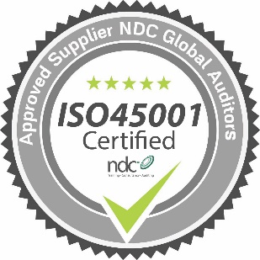Strict legislation demands that organisations show a clear, pro-active commitment towards the health and safety of their employees. The ISO 45001 certification enables Hydram to demonstrate its commitment to occupational health and safety.

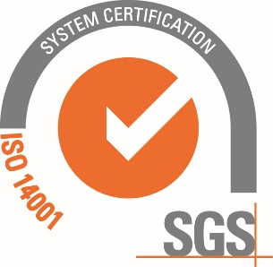Hydram constantly reviews its progress against environmental performance targets set out in ISO 14001 which include pollution prevention, reducing carbon footprint, minimising use of packaging, and waste segregation

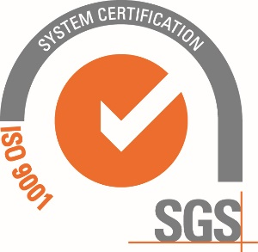 In order to continually meet the requirements of ISO 9001 Hydram operates fully documented Quality Procedures. Hydram work to formal processes such as APQP and PPAP if required.

6701

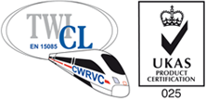 Hydram is certified to BS EN 15085 Class 1, the top level of accreditation for Welding of Railway Vehicles and Components (CWRVC.

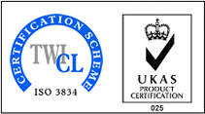 The ISO3834-2:2005 standard defines comprehensive quality requirements for fusion welding of metallic materials.

ACCREDITATIONS – WORKING

TO THE HIGHEST STANDARDS